Depth First Search (DFS)
Aim
To traverse or search all the vertices of a graph/tree by exploring as far as possible along each branch before backtracking.

Python Program
# Depth First Search using recursion

graph = {
'A': ['B', 'C'],
'B': ['D', 'E'],
'C': ['F'],
'D': [],
'E': [],
'F': []
}

visited = set()

def dfs(node):
if node not in visited:
print(node, end=" ")
visited.add(node)

for neighbor in graph[node]:
dfs(neighbor)

dfs('A')

Output
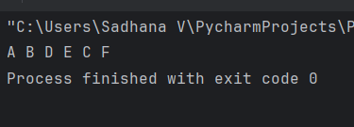
Flowchart
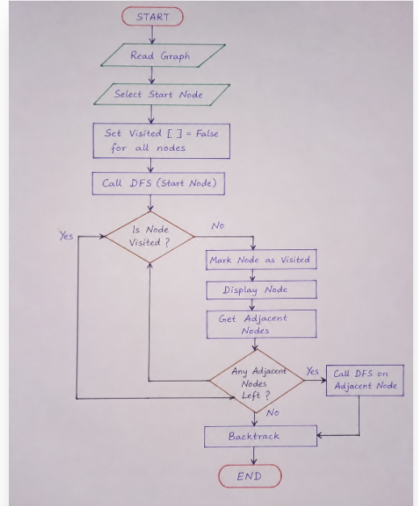
Result
Thus, the Depth First Search (DFS) algorithm was implemented successfully in Python and the graph was traversed in DFS order as:
A → B → D → E → C → F

